Draw a Use case diagram to model for a quiz system. A user can request a quiz for system. The system picks a set of questions from its database, and composes them together to make a quiz. It rates the user’s answers and gives hints if the user requests it. In addition to users, we also have helpers who provide questions and hints. And also, administrators who must certify questions to make sure they are not too trivial, and that they are correct

## **Aim**

To design a **Use Case Diagram** for a **Quiz System** that models the interactions between users, helpers, administrators, and the system itself, ensuring a structured quiz management process.

## **Procedure (Step-by-Step Process)**

### **Step 1: Identify the Key Actors**

The system involves three primary actors:

1. **User** – Takes the quiz, answers questions, and requests hints.
2. **Helper** – Provides questions and hints for the quiz.
3. **Administrator** – Certifies the quality and correctness of questions.

### **Step 2: Identify the Use Cases**

#### **1. User Actions**

* **Request Quiz** – The system selects and composes a quiz.
* **Answer Questions** – The user submits answers.
* **Request Hint** – The user requests hints for difficult questions.
* **Receive Rating** – The system evaluates and rates the user's performance.

#### **2. Helper Actions**

* **Provide Questions** – Adds new quiz questions to the system.
* **Provide Hints** – Supplies hints for the quiz questions.

#### **3. Administrator Actions**

* **Certify Questions** – Reviews and approves questions to ensure quality.

### **Step 3: Define the Relationships**

* **User interacts with the Quiz System** to request a quiz, answer questions, request hints, and receive a rating.
* **Helper interacts with the Quiz System** to provide questions and hints.
* **Administrator interacts with the Quiz System** to certify the correctness and difficulty of questions.

### **Step 4: Draw the Use Case Diagram**

* Represent **Actors** as stick figures.
* Represent **Use Cases** as ovals.
* Use **Associations** (lines) to connect actors with use cases.
* Enclose the use cases within a **system boundary** labeled **"Quiz System"**.

### **Use Case Diagram**

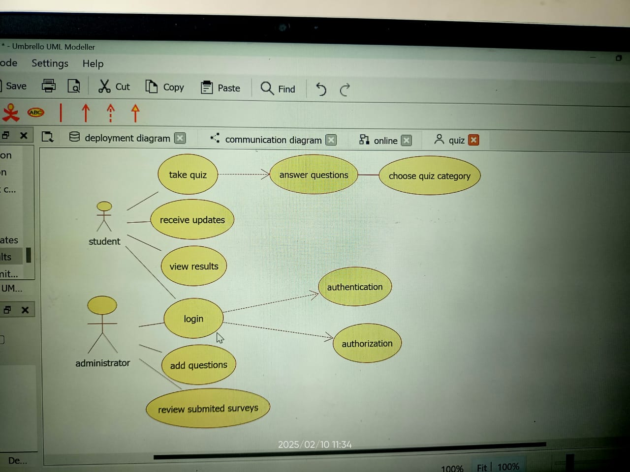

## **Result**

The **Use Case Diagram for the Quiz System** successfully represents the interactions between **users, helpers, administrators, and the quiz engine**. It ensures a structured workflow where users can take quizzes, helpers can contribute questions, and administrators maintain the quality of content. This diagram serves as a **blueprint** for developing an effective and interactive quiz system.